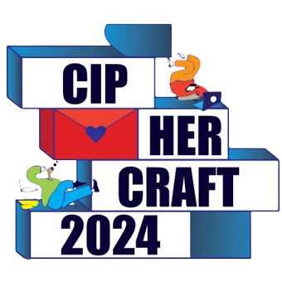

Memorandum of Understanding (MOU)

Between

CIPHER CRAFT

And

HOSTHAPS

Description:

Cipher Craft is a dynamic tech event where people passionate about coding and entrepreneurship come together to explore new ideas and push the limits of technology. It's a place where you can learn, create, and connect with like-minded individuals through hackathons, workshops, and networking opportunities.
Event Details:

Following is the Event Highlights of Cipher Craft 2024:
- Registration: Participants will complete their registration by presenting their CNIC/ID Card (University Card) and Verification Code (Luma) to ensure a smooth process.
- Breakout to Rooms & Team Formation: Attendees will be guided to designated rooms. Teams of 2 to 4 hackers will be formed, laying the foundation for collaborative hacking.
- Project Ideation: Teams will create a comprehensive project plan, outlining key tasks, milestones, and timelines to steer their development process.
- Project Development: Teams will start working on their ideas, transforming them into tangible projects.
- Refreshment Break: Participants will enjoy a quick snack to recharge their energy.
- Workshop: A hands-on session aimed at boosting productivity through multiple workshops that may include (GitHub, Notion, Neural Networks, Game Jam with Unity etc.)
It is a fantastic opportunity to learn new skills, meet new people, and have a lot of fun. Join us and push the boundaries of technology.
Purpose of this MOU:

To formalize the collaboration between the Cipher Craft Team and HostHaps for Cipher Craft 2024, this partnership aims to pool resources and expertise to create an inclusive tech event. Cipher Craft 2024 will include hackathons, interactive workshops, and networking opportunities, promoting innovation, community, and learning. This MoU highlights our commitment to mutual growth and development through shared knowledge and student opportunities.
Responsibilities:

The HostHaps and Cipher Craft Team agrees to the following tasks for this MOU:
Responsibilities of HostHaps under this MOU
HostHaps shall undertake the following activities:
- HostHaps will provide short-listed candidates by Cipher Craft with hosting and domain free of cost.
- HostHaps will repost the collaboration post made by Cipher Craft team on their social media.
Responsibilities of Cipher Craft team under this MOU
Cipher Craft Team shall undertake the following activities:
- Cipher Craft will post collaboration post with HostHaps on their socials as an industry partner.
- Cipher Craft will place the logo of HostHaps on their website.
- Cipher Craft will place the logo of HostHaps on the main flex on
the day of Event.
- Cipher Craft will invite the representative of HostHaps as a judge.

Signature:

This MOU shall be affected upon the signature of both parties authorized officials



____________________________________ ________________________________
Name Muhammad Nouman
Title Organizer Cipher Craft

____________________________________ ________________________________
Date Date



